Monitor Log files and errors

- All the logs and messages stored in:

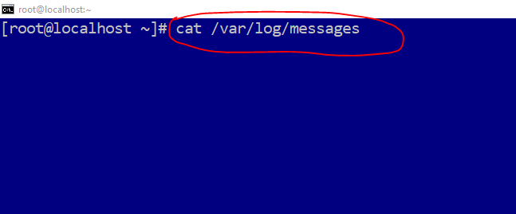

- For continuously monitoring the logs…
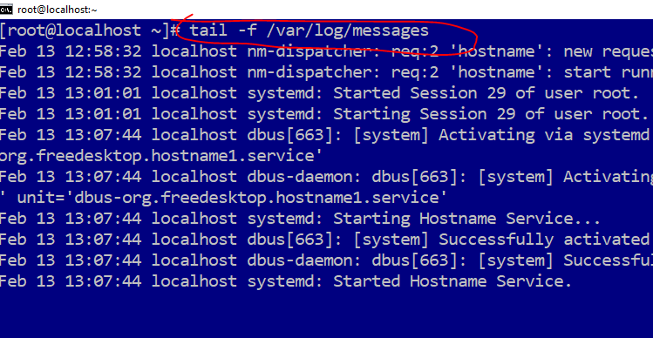

Dmesg –T | tail

